**Apt 3065 B: MID TERM PROJECT**

**Professor: Chrispus Alukwe**

**Chapter Two: Literature Review**

**By**

**Tapiwa Civil Chimbwanda 662676**

**CHAPTER TWO**

# **Introduction**

**Topic Sentence**

Creating a ground-breaking platform to empower retail traders to change the way they navigate the financial markets in an industry where 90% of individuals experience a staggering 90% loss within just 90 days, the system aims to provide traders with insights and tools to not only track their progress but also establish a competitive edge (IMARC Group, 2022).

This project aimed to evaluate trading activity in markets without examining specific strategies or their existence. It focused on assessing the overall impact of the trader's actions to determine if it demonstrated a positive or negative outcome. The goal was to determine if these activities were favourable for potential investors considering capital allocation.

## **Review of objective one :**

## **To build a system that has metrics and financial analytics that determines whether a trader is profitable or not and if not are they progressively improving.**

Retail investors are individual investors who trade in relatively small quantities of capital, as opposed to institutional investors who have millions if not billions in assets under management. This objective is particularly relevant to them as they often lack the resources and expertise of institutional investors and may benefit greatly from automated tools to assess their performance.

Existing literature acknowledges the importance of metrics and analytics in trading. Metrics such as Sharpe ratio, maximum drawdown, win rate, and others are commonly used to evaluate trading performance. However, the retail investors lack access to these sophisticated systems and metrics for example according to Bank of International Settlements recent crypto trading activities showed increased losses for retail traders as a result of sophisticated investors selling and smaller retail investors buying (Giulio Cornelli, 2023).

The idea of monitoring progressive improvement in trading is supported by literature. Many successful traders emphasize the importance of continuous learning and adapting strategies over time mainly because there are many changing components from an economic and political perspective like interest rates and wars that affect the markets in an unpredictable manner. Therefore, there is need to monitor change to adapt accordingly and with that comes the need to progressively monitor improvement in new environments

## **Review of objective two:**

## **To build a system that performs reporting and visualization by presenting performance data in a clear and understandable graphical interface that is customizable and interactive which the trader can present as a prototype of their strategy and results to any investor or interested party**

Studies highlight the significance of clear and intuitive visualization for retail investors who may not have the same level of expertise as institutional investors. Visual representations can help them make informed decisions and understand the performance of their investments on a macro scale since they are mostly focused on the current positions and daily activities. It makes it hard to make and keep a long-term mental map of their performance.

Enabling retail traders to present their strategies and results to potential investors addresses a key aspect of seeking external funding or partnerships. Literature on start-up pitching and investment presentations emphasizes the need for clear, compelling visualizations across all business as it is a good form of communication (Iwona Sobol, 2020).

Empowering retail investors with tools for reporting and visualization aligns with the trend of democratizing access to financial information and trading technology. It emphasized that the importance of providing retail investors with user-friendly tools and platforms is crucial for success.

## **Review of objective three:**

## **To build a system that has trade history and activity logging in a data database schema for trade records, including entry/exit prices and volumes**

Maintaining a comprehensive trade history with detailed activity logging is considered a fundamental practice in trading. It allows traders to review and analyse their past trades, which is crucial for learning from successes and mistakes and tweaking strategies in relation to current market conditions, which are always changing.

Retail investors, especially those who manage their own portfolios, benefit greatly from robust record-keeping systems. Importance in personal finance and investment management emphasizes the need for accurate and detailed trade records if growth is to be realized

Literature highlights the significance of effective risk management in trading. It allows traders to assess their risk exposure, track position sizes, and make adjustments to their strategies as needed..

## **Review of objective four:**

## **To build a system that has user authentication and profile management system for traders to access their accounts and manage their profiles.**

User authentication is a critical security measure in any digital platform, particularly in financial services. The importance of robust authentication mechanisms to protect user accounts from unauthorized access is key part to ensure data integrity.

Allowing traders to manage their profiles is a standard feature in modern financial platforms. This enables users to update personal information, set preferences, and customize their experience. The significance of user-centric interfaces for enhancing engagement

## **Concept map**

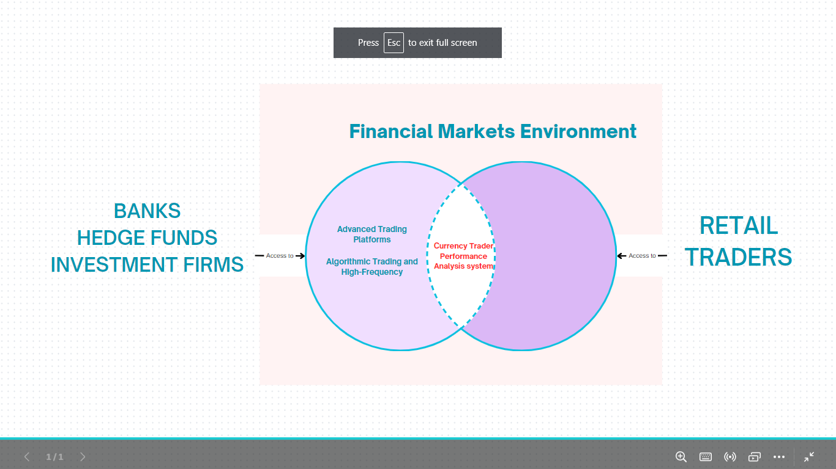

The above diagram shows the imbalance in resource access between institutions and retail traders participating in the financial markets as a result of monopolization and privatization of resources which created a gap in the middle which I addressed with the system I built so as to give retail traders an edge in the markets

# **References**

Giulio Cornelli, S. D. (2023). Crypto shocks and retail losses. *BIS Bulletin*.

IMARC Group. (2022). *Foreign Exchange Market: Global Industry Trends, Share, Size, Growth, Opportunity and Forecast 2023-2028.* IMARC Group.

Iwona Sobol, M. S. (2020). Retail investors in the foreign exchange market. *RESEARCH PAPERS OF WROCLAW UNIVERSITY OF ECONOMICS AND BUSINESS*.